Ayush Goyal
190905522 CSE D Roll 62

Operating Systems Week 8: Lab 7: IPC-3: Deadlock, Locking, Synchronization

Lab Excercises:

1. Modify the above Producer-Consumer program so that, a producer can produce at the most 10 items more than what the consumer has consumed.

Code:

#include<stdio.h>
#include<unistd.h>
#include<pthread.h>
#include<semaphore.h>

int buf[5], f, r;
sem_t mutex_sem, end, start;

void *produce(void *arg){
for(int i=0;i<10;i++){
sem_wait(&start);
sem_wait(&mutex_sem);

printf("Produced Item is : %d\n",i);

buf[(++r)%10] = i;
sleep(1);

sem_post(&mutex_sem);
sem_post(&end);
}
}

void *consume(void *arg){
int item;
for(int i=0;i<10;i++){
sem_wait(&end);
sem_wait(&mutex_sem);

item = buf[(++f)%10];
printf("Consumed Item is : %d\n", item);
sleep(1);

sem_post(&mutex_sem);
sem_post(&start);
}
}

int main(){
pthread_t t1, t2;
sem_init(&mutex_sem, 0, 1);
sem_init(&end, 0, 1);
sem_init(&start, 0, 10);
pthread_create(&t1, NULL, &produce, NULL);
pthread_create(&t2, NULL, &consume, NULL);
pthread_join(t1, NULL);
pthread_join(t2, NULL);
return 0;
}

Output:

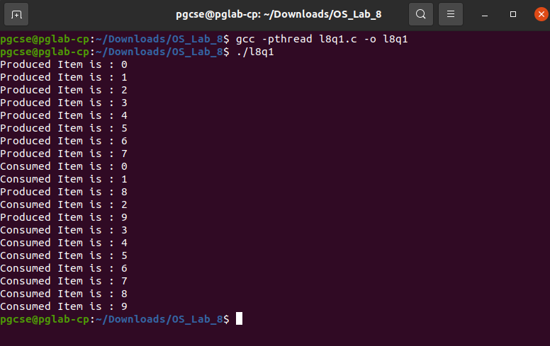

2. Write a C program for the first readers-writers problem using semaphores.

Code:

#include<stdio.h>
#include<unistd.h>
#include<pthread.h>
#include<semaphore.h>

sem_t wrt;
pthread_mutex_t mutex_sem;
int count = 1;
int numreader = 0;

void *writer(void *wno){
sem_wait(&wrt);
count *= 2;
printf("Writer %d modified 'count' to %d\n", (*((int*)wno)), count);
sem_post(&wrt);
}

void *reader(void *rno){
pthread_mutex_lock(&mutex_sem);
numreader++;

if(numreader == 1)
sem_wait(&wrt); //first reader will block the writer
pthread_mutex_unlock(&mutex_sem);

//Reading Section, hence no locks

printf("Reader %d: read 'count' as %d\n", *((int*)rno), count);

//Reader acquire the lock before modifying numreader

pthread_mutex_lock(&mutex_sem);
numreader--;

if(numreader == 0)
sem_post(&wrt); //If this is the last reader, it will wake up the writer
pthread_mutex_unlock(&mutex_sem);
}

int main(){
pthread_t read[10], write[5];
pthread_mutex_init(&mutex_sem, NULL);
sem_init(&wrt, 0, 1);
int a[10] = {1,2,3,4,5,6,7,8,9,10}; //used for numbering the producers and consumers

for(int i=0;i<10;i++)
pthread_create(&read[i], NULL, reader, &a[i]);
for(int i=0;i<5;i++)
pthread_create(&write[i], NULL, writer, &a[i]);
for(int i=0;i<10;i++)
pthread_join(read[i], NULL);
for(int i=0;i<5;i++)
pthread_join(write[i], NULL);

pthread_mutex_destroy(&mutex_sem);
sem_destroy(&wrt);
return 0;
}

Output:

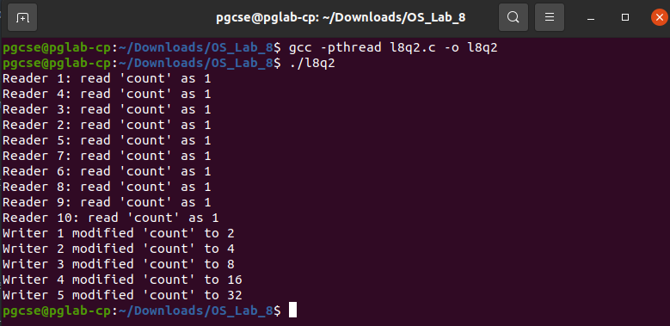

3. Write a code to access a shared resource which causes deadlock using improper use of semaphore.

Code:

#include<stdio.h>
#include<unistd.h>
#include<pthread.h>
#include<semaphore.h>

sem_t s1, s2;

void *func1(void *p){
sem_wait(&s1);
sem_wait(&s2);
printf("Thread 1!\n");
sem_post(&s1);
}

void *func2(void *p){
sem_wait(&s2);
sem_wait(&s1);
printf("Thread 2!\n");
sem_post(&s2);
}

int main(){
pthread_t threads[2];
sem_init(&s1, 0, 1);
sem_init(&s2, 0, 1);
pthread_create(&threads[0], 0, &func1, 0);
pthread_create(&threads[1], 0, &func2, 0);
pthread_join(threads[0], 0);
pthread_join(threads[1], 0);
sem_destroy(&s1);
sem_destroy(&s2);
}

Output:

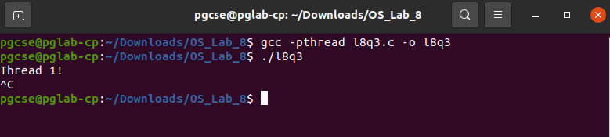

4. Write a program using semaphore to demonstrate the working of sleeping barber problem.

Code:

#include<stdio.h>
#include<stdlib.h>
#include<unistd.h>
#include<pthread.h>
#include<semaphore.h>

sem_t customer, barber;
pthread_mutex_t seat;
int free1 = 10;

void *barb(void *args){
while(1){
sem_wait(&customer);
pthread_mutex_lock(&seat);

if(free1 < 10)
free1++;
sleep(2);

printf("Cutting Completed! Free Seats: %d\n", free1);
sem_post(&barber);

pthread_mutex_unlock(&seat);
}
}

void *cust(void *args){
while(1){
pthread_mutex_lock(&seat);

if(free1 > 0){
free1--;
printf("Customer Waiting! Free Seats: %d\n", free1);
sem_post(&customer);
pthread_mutex_unlock(&seat);
sem_wait(&barber);
}
else
pthread_mutex_unlock(&seat);
}
}

int main(){
pthread_t threads[2];
sem_init(&barber, 0, 1);
sem_init(&customer, 0, 1);
pthread_mutex_init(&seat, 0);
pthread_create(&threads[0], NULL, &barb, NULL);
pthread_create(&threads[1], NULL, &cust, NULL);
pthread_join(threads[0], NULL);
pthread_join(threads[1], NULL);
sem_destroy(&barber);
sem_destroy(&customer);
pthread_mutex_destroy(&seat);
}

Output:

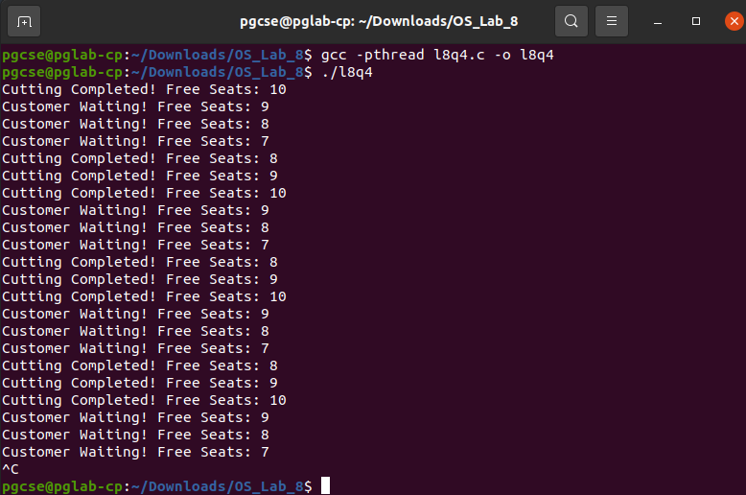

THE END

